**Introducing SkyInsights: Crypto Compliance Made Easy**

**2023/9/13**

Blockchain technology provides new avenues for investment, payment, and the secure functioning of decentralized applications. However, with this innovation has come a surge in regulatory scrutiny. In the words of the [US Department of the Treasury](https://home.treasury.gov/system/files/136/DeFi-Risk-Full-Review.pdf), “DeFi service[s] … will be required to comply with BSA obligations, including anti-money laundering (AML) and countering the financing of terrorism (CFT) obligations”.

[Crypto compliance](https://certik.medium.com/keeping-in-the-clear-what-is-crypto-compliance-74602e8f8119) is the bridge between the disruptive power of blockchain and the representative authority of established regulations. It ensures that financial institutions and crypto firms operate within a secure environment, employing appropriate risk management strategies and due diligence measures. Crypto compliance is not merely a reactive response to regulatory pressures; it's a proactive step towards legitimizing and fostering trust in Web3.

In recognition of this fact, CertiK is proud to introduce SkyInsights, a powerful crypto compliance and risk management platform. With a suite of features including wallet screening, real-time transaction monitoring, and customizable alerts, SkyInsights helps financial institutions, small-to-medium firms, and crypto-native platforms navigate the complexities of compliance.

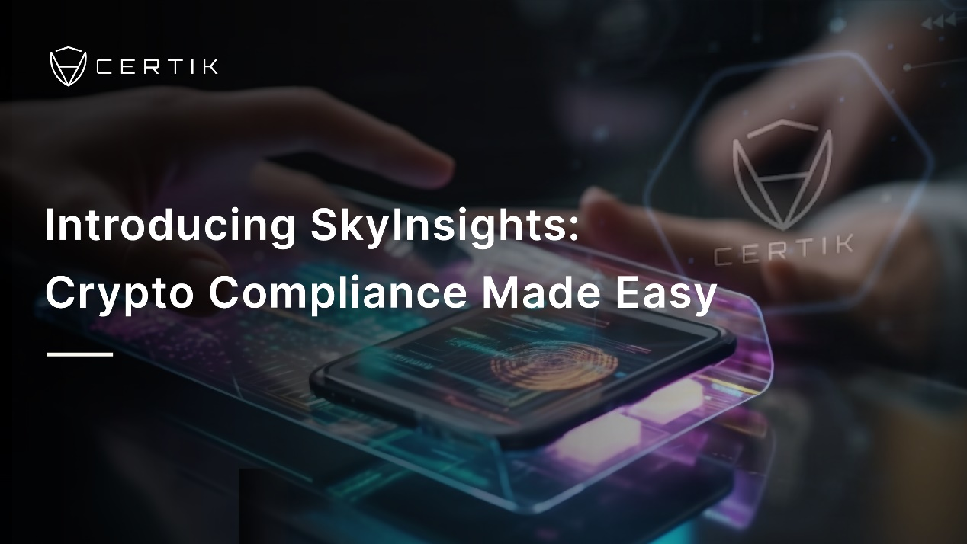

**Simplifying Crypto Compliance: SkyInsights' Features**

Navigating the labyrinth of crypto compliance can be a daunting task, but with the right tools it becomes manageable, systematic, and effective. SkyInsights helps VASPs make compliance not just a requirement but an enhancement to business processes and client trust.

**Wallet Screening**

The SkyInsights Wallet Screening dashboard offers an intuitive interface that enables a thorough analysis of the risk associated with specific wallets. This includes connections to sanctioned entities, exposure to risky wallets, historical transactions, and other critical factors that could pose a threat. By conducting wallet screening, businesses can avoid inadvertent participation in malicious activities, thereby safeguarding their assets and reputation.

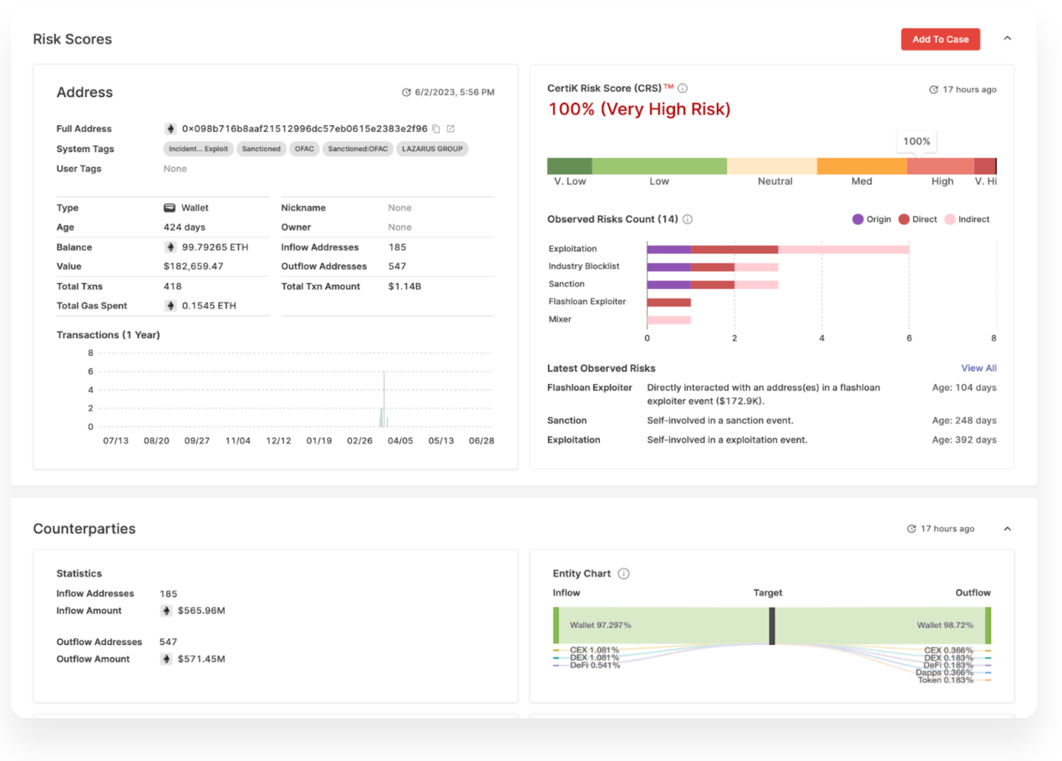

**Know Your Transaction (KYT)**

Getting to "Know Your Transaction" (KYT) extends beyond merely identifying the parties involved in a transaction to understanding the very essence and purpose of it. KYT involves the general monitoring and analysis of cryptocurrency transactions in order to paint an accurate picture of on-chain activity and identify suspicious transactions.

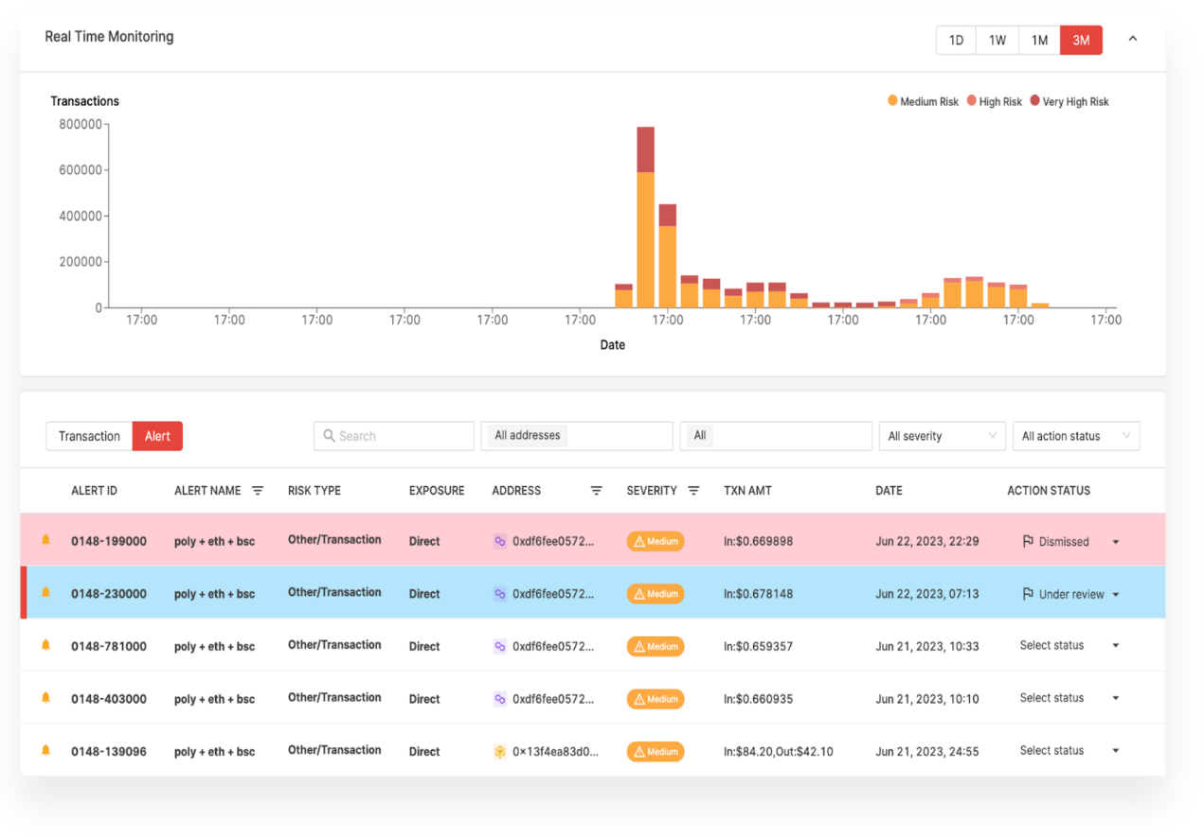

With features like alert tables, segmented risk severity counts, and convenient audit trails, the transaction monitoring tool makes knowing your transactions a manageable and insightful process. Whether it's tracking alert actions or comparing risk scores, SkyInsights' transaction monitoring software provides a nuanced understanding of transactions.

**Customizable Solutions**

**Monitoring Groups**

The need for adaptable and personalized solutions is a key requirement for compliant firms. SkyInsights' Monitoring Group capabilities allow for a high degree of customization that caters to individual business needs. It recognizes that no two cases are identical and offers the flexibility to tailor processes accordingly.

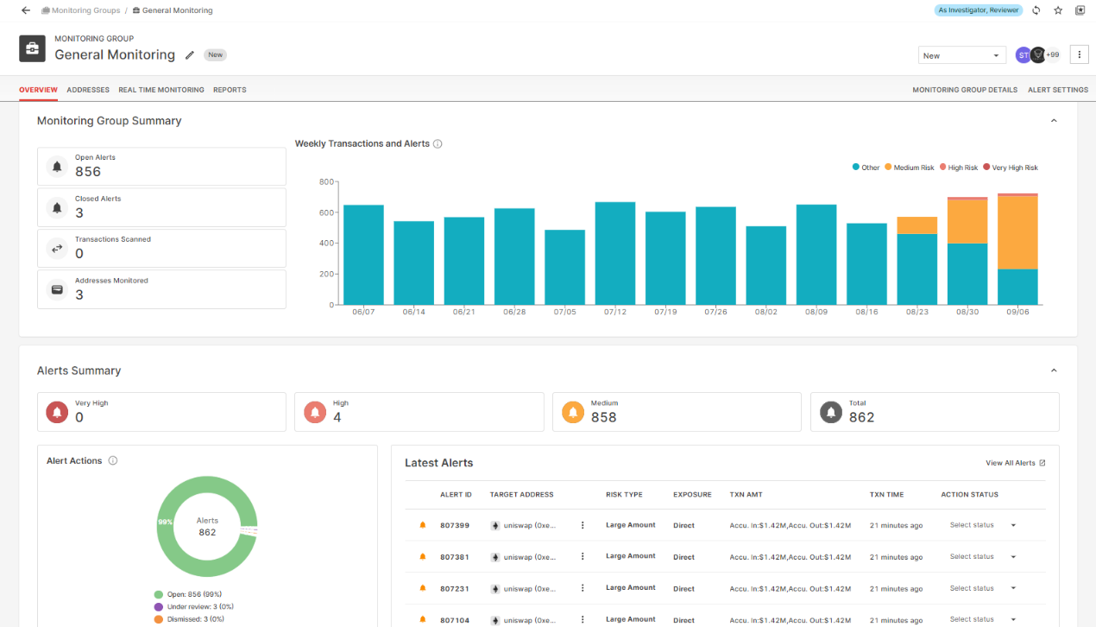

Monitoring Groups offer insights into transaction timelines, alert statuses, and changes in risk levels. These are further enriched with weekly reports at the group level, which can be automatically generated and shared. Monitoring Groups give you the ability to compare an address's current score to its previous score, allowing for a dynamic understanding of changes in risk profile. The dashboard also offers real-time transaction monitoring, overlaying transactions with alerts, as well as a live feed of transactions. These functionalities combine to provide a comprehensive view of wallet-level risk assessments.

**Prompt Alerts and Escalations**

Responsiveness is crucial in the fast-paced world of crypto. SkyInsights ensures that real-time transaction monitoring is accompanied by prompt alerts and easy escalations. The Alert Table's advanced filters allow for efficient organization, facilitating immediate review and dismissal of alerts.

With a system that keeps track of all recent alerts and overlays transactions with alerts, VASPs can be confident they’re maintaining a vigilant and proactive stance against suspicious activities. Alerts are not just indicators but actionable insights that enable quick and effective responses.

**Audit Trails and Reports**

Transparency and accountability are foundational to SkyInsights' approach. The platform automatically logs all actions taken on any address within a case, providing an in-depth view for auditors.

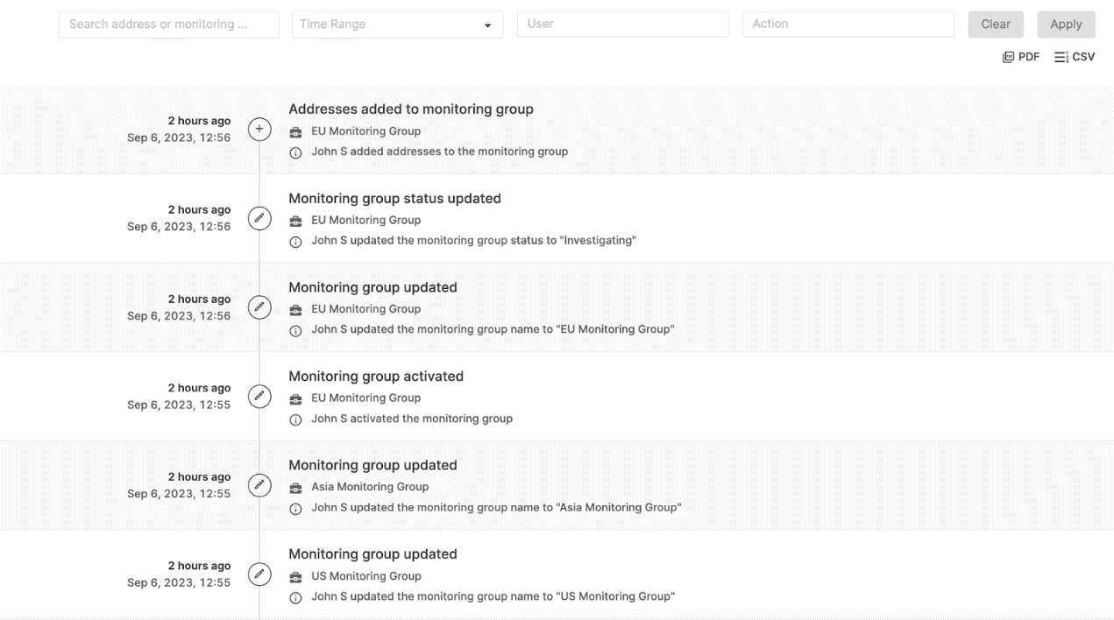

These logs can be conveniently downloaded as PDFs, creating a transparent trail of activities that aids in compliance and due diligence. Weekly and on-demand reports provide additional layers of transparency, catering to various needs, whether for specific address inquiries within a designated timeframe or general monitoring.

Customizable case management aligns with unique business needs, while prompt alerts and escalations provide timely responses to potential threats. The seamless integration of audit trails and reports ensures that every action is documented and easily accessible.

**SkyInsights API**

**Integration and Automation**

The SkyInsights API seamlessly integrates with existing systems, providing a streamlined approach to crypto compliance. Automation capabilities not only reduce manual intervention but also significantly enhance efficiency, enabling businesses to keep pace with the fast-evolving cryptocurrency landscape.

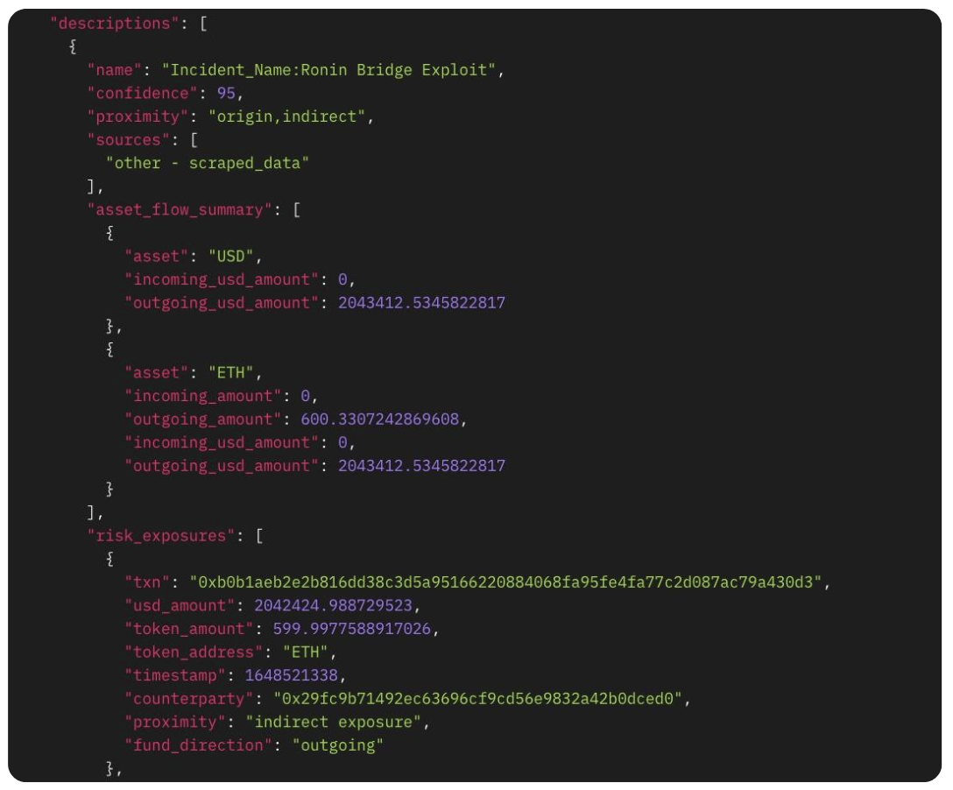

**Risk Assessment and Management**

The API delivers industry-standard risk assessments, accommodating a wide array of factors including wallet attributes, labels, historical transactions, exposure to risky wallets, sanctions, and other critical considerations. Through real-time transaction monitoring and risk scores, it offers a comprehensive and proactive approach to identifying potential financial crime while reducing false positives.

**Scalable and Adaptable**

Designed with scalability in mind, SkyInsights API ensures that the compliance requirements of businesses of all sizes are met without compromising performance. Its adaptability is not just in how it fits into various business models but also in its capacity to evolve with emerging trends, regulations, and technologies.

**Conclusion**

As the Web3 landscape continues to evolve, so does the complexity of navigating the regulatory terrain that surrounds it. Staying ahead of compliance requirements is no longer just a matter of due diligence; it's a strategic imperative for any business involved in cryptocurrency transactions. SkyInsights, with its comprehensive suite of tools, provides the answer to this challenge.

From wallet screening to transaction monitoring, from customizable case management to robust audit trails, SkyInsights gives VASPs a simple and holistic approach to crypto compliance.

SkyInsights’ KYT and real-time transaction monitoring go beyond traditional financial safety checks, presenting a nuanced and insightful framework for risk management. The SkyInsights API, the backbone of the system, prioritizes adaptability and scalability, crafting a solution that can grow and evolve with the ever-changing crypto landscape. Its real-time capabilities reflect a deep understanding of both the technological opportunities and the practical necessities of the contemporary Web3 world. SkyInsights empowers VASPs to navigate this complex realm while ensuring they align with both the letter and the spirit of the law.

[Get compliant with SkyInsights today](https://www.certik.com/products/skyinsights).

<https://www.certik.com/zh-CN/resources/blog/4GiRbZdV1pminOKu8OUtJF-introducing-skyinsights-crypto-compliance-made-easy>